Revision History

|  |  |  |
| --- | --- | --- |
| **Revision** | **Description of Change** | **Revision date** |
| 1.0 |  | 2018-08-13 |
|  |  |  |
|  |  |  |
|  |  |  |

**TABLE OF CONTENTS**

[Introduction 2](#_Toc521943062)

[1 Test Object 2](#_Toc521943063)

[2 Test Environment 4](#_Toc521943064)

[3 Testing work （Phase 1） 5](#_Toc521943065)

[3.1 Test scenario and strategy 5](#_Toc521943066)

[3.2 Test Tool 6](#_Toc521943067)

[3.3 Other Setting: 6](#_Toc521943068)

[Database setting 6](#_Toc521943069)

[IIS setting 6](#_Toc521943070)

[3.4 Test Object version 6](#_Toc521943071)

[3.5 Background data 6](#_Toc521943072)

[3.6 Test Conclusion 7](#_Toc521943073)

[3.7 Suggestion 8](#_Toc521943074)

[4 Testing work （Phase 2） 8](#_Toc521943075)

[4.1 Test scenario and strategy 8](#_Toc521943076)

[4.2 Test Tool 9](#_Toc521943077)

[4.3 Other Setting: 9](#_Toc521943078)

[Database setting 9](#_Toc521943079)

[IIS setting 9](#_Toc521943080)

[4.4 Test Object version 9](#_Toc521943081)

[4.5 Background data 9](#_Toc521943082)

[4.6 Test Error 10](#_Toc521943083)

[4.7 Test result of PS server 11](#_Toc521943084)

[Test result of PS transactions 11](#_Toc521943085)

[Test Statistic Report of PS 11](#_Toc521943086)

[Transaction summary result of PS 13](#_Toc521943087)

[Transaction response time result of PS 13](#_Toc521943088)

[4.8 Test result of Web service 14](#_Toc521943089)

[Test result of web transactions 14](#_Toc521943090)

[Test Statistic Report of Web 15](#_Toc521943091)

[Transaction summary result of Web 17](#_Toc521943092)

[Transaction response time result of Web 17](#_Toc521943093)

[4.9 Performance bottleneck analysis 19](#_Toc521943094)

[Hardware usage analysis 19](#_Toc521943095)

[SQL Server resource usage analysis 23](#_Toc521943096)

[4.10 Test Conclusion 26](#_Toc521943097)

# Introduction

The PUMA performance testing works will focus on main work flow of the Print Server of Kiosk (PS).

The PUMA PS system will integrated with other 3rd systems like HIS, RIS, LIS etc. System will synchronize 3rd party data and provide the film and report printing services. The Cloud Film system will integrate with PS and get the patient information and images data from PS system.

We should confirm the performance of PS system will meet the requirements on real work environments. Ensure the images upload service of Cloud Film will not affect main workflow of PS system.

# Test Object

The PUMA system will support film and report printing and notice push service for different departments of entire hospital.

We will integrate the 3rd party system and patients can print their reports in ONE terminal. The message push service will also be included in the product. Patients can query different information, and get report status notice service from the product.

PUMA MR1 system will provide the patient images data upload service for Cloud Film system. The patient can view the image files including picture and DICOM type from WeChat platform or by scanning from 2D image code.

The architecture as follow:

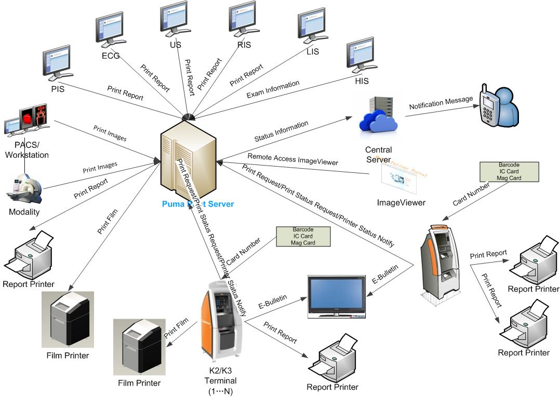Figure 3.1.2

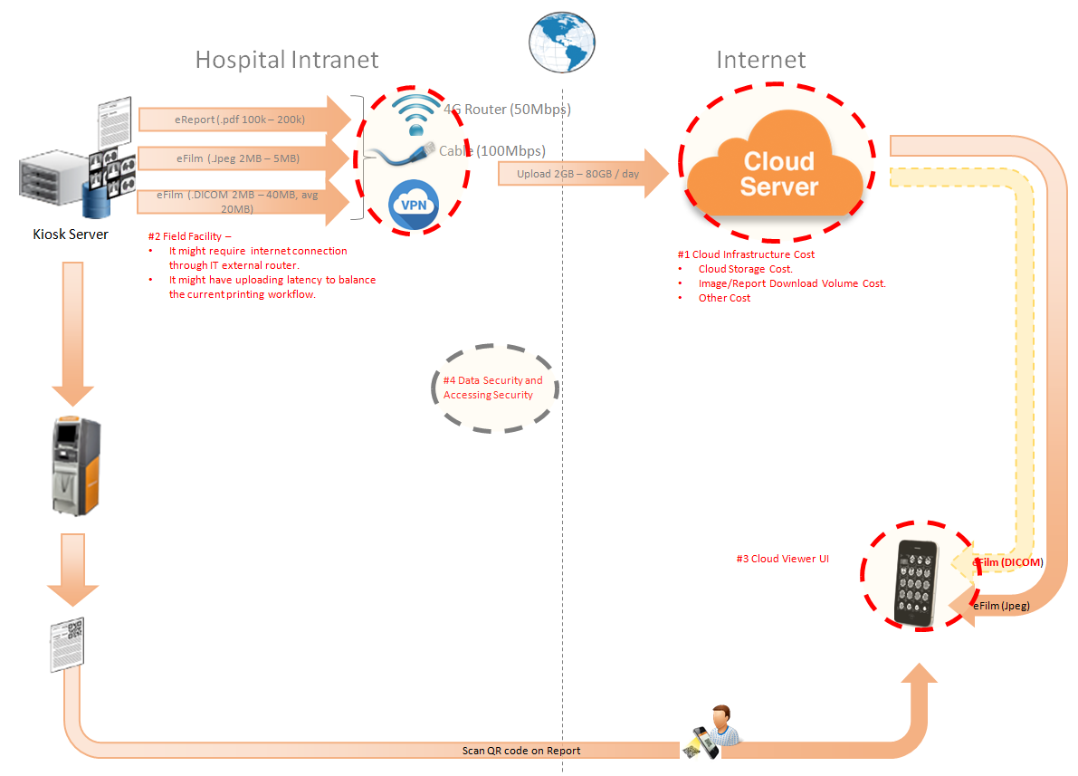Figure 3.1.2

The performance testing work will focus on the PS system. We will simulate the web service call and send them to PS server, and monitor the transactions response time, service performance and hardware resource usage. This scenario will include the 3rd request, report archived, film and report print, image files upload and web query, update operations etc.

# Test Environment

The detailed hardware configurations of all servers are described as follow:

|  |  |  |  |  |  |  |
| --- | --- | --- | --- | --- | --- | --- |
| **Computer name** | **CPU** | **Memory** | **HD** | **OS** | **Other** | **Comments** |
| PS Server Panda upgrade | Interl(R) Xeon® CPU E5-2350 @ 1.80 \* 6 | 16GB | 1TB | Windows 2008 R2 64bit | SQL server workgroup 2008 | Limit the local net width to 20MBps. |
| Workstation Server | Intel i3-2120 3.3GHz | 2GB | 80GB | Windows 7 SP1 64bit | QTP 11 | 6 virtual machine in server |
| Terminal | Intel Atom D525 1.8GHz | 4GB | 450GB | Windows Embedded Standard SP1 64bit | UTF 12.0 trail |  |
| Cloud Film Server | Interl(R) Xeon® CPU E5-2620 @ 2.40 \* 6 | 64GB | 1T | Windows server2016 Standard 64 bit | Mock server from develop |  |
| Cloud film DB Server | Interl(R) Xeon® CPU E5-2620 @ 2.40 \* 6 | 64GB | 1T | Windows server2016 Standard 64 bit | Mysql 5.6 |  |

Table 1 Hardware Configuration

# Testing work （Phase 1）

## Test scenario and strategy

Virtual User: 21 Users

Duration: 8 hour

Description: Use the test tool simulates the patient operations. Monitor the server software and hardware resource usage. The detail information as follow:

1. Use automation tool simulate the doctor print film work. Simulate 6 GX Platform by using QTP and WinDPSTester tool. Each client prints one film which size is 10MB every 30 seconds.
2. Use LR tool simulate 8 K2/K3 terminals to print film. Each client prints one film which size is 10MB random 5 to 30 seconds.
3. Use LR tool simulate 8 users to do report archive operations. Each client archive report in random 5 to 30 seconds and size is random with 100kb and 4Mb.
4. Use LR tool simulate 8 terminals to print paper reports. Each client prints report random 5 to 30 seconds.
5. The OCR setting is not has rule for GX platforms in step1 and other setting are set as default. The OCR service will under the strong stress without configure the rule.
6. Simulate 5 users to do the query information, view monitor page, query reconciliation films and report, expand the record, change the status, set holding time and other operations in worklist.
7. Monitor the transaction response time.
8. Monitor the hardware resource usage on PS.
9. Monitor the resource usage for database on PS.
10. Start/Stop 2 virtual users every 10 seconds and run the scenario for 8 hours.
11. Simulate the Upload network bandwidth to 20M.

Note:

We will do the performance testing work under big stress for system. If system can work well under current stress and the transaction process ability meets the requirement, we will give the conclusion the system performance is pass.

## Test Tool

LoadRunner 12.

## Other Setting:

### Database setting

Memory: Set the min and max memory size to 4GB.

Index fill factor: 80.

File: Increase the data and log files size and the rule is increase 200Mb as fixed size.

### IIS setting

Connection: Set the max connection value to 4000 and keep other setting as default.

## Test Object version

KIOSK cloud film 3.0.3.0 B23

## Background data

We prepared a background records in the PS system. The data size is calculated by the typical site which printed 3,000 films in a workday. That means the records of films in db should more than 972,000 (3000records / day \*54 weeks \* 6 workday). QA team had prepared these data with SQL script and automation script. These data can backup and import by DB tool.

The detail data records in DB as follow:

|  |  |
| --- | --- |
| **Table Name** | **Data Volume (records)** |
| printer.dbo.DeliveryJob | 995199 |
| printer.dbo.ImageBox | 3530116 |
| printer.dbo.Page | 314893 |
| printer.dbo.Session | 571212 |
| wggc.dbo.Patient | 1224710 |
| wggc.dbo.Study | 1434574 |
| wggc.dbo.AFP\_PrintTerminalInfo | 70 |
| wggc.dbo.Series | 1434524 |
| wggc.dbo.Image | 1434527 |
| wggc.dbo.AFP\_FilmInfo | 1420905 |
| wggc.dbo.AFP\_ReportInfo | 1232003 |
| wggc.dbo.AFP\_ExamInfo | 2308723 |
| wggc.dbo.AFP\_PrintTask | 4324918 |
| wggc.dbo.T\_Integration\_ExamInfo | 1421769 |
| AFP\_PrintMode | 523684 |
| wggc.dbo.vi\_KIOSK\_ExamInfo\_Order | 838208 |

## Test Conclusion

The develop team offer a mock service and QA team limit the net width to 20Mbps. The system performance does not meet the requirements of design. The DICOM and report upload operation cannot work well and some issues exist in the database. The detail information as follow:

1. The upload file queue will block if the queue is more than default value. It cause by the SQL statement in the database.
2. The ACQ service will cause the database locks if script try to insert patient information to table patient in database wggc.
3. The patient report will not upload if patient only has report because the patient has not patient information in database. The patient information will create when their image archived in system.
4. The patient information created will failed when the patient age has character like “YMD” in DICOm files. Need change the column property in database.

QA team had submitted the defects in PLI to record these issues:

|  |  |
| --- | --- |
| Event Number | Title |
| 100048496 | [Performance] The upload queue will block when maxuploadfile value more than default one. |
| 100048495 | [Performance]There are table lock issue exist in the database for acq service of PS. |
| 100048438 | [Cloud Film]The patient report will not upload if patient only has report. |
| 100048437 | [Cloud Film] The column patientage type should not be int in ECS and CS database . |

## Suggestion

1. Fix the defects which had submitted by QA team.
2. Enhance the SQL statement of “wggc.dbo.AFP\_SP\_GetExamsForSyncToECS”. This store procedure is the root reason of defect 10048496.
3. Change the design of files upload logic. Reduce the number of upload thread. The reliability of service is important than the performance for our system.

# Testing work （Phase 2）

## Test scenario and strategy

Virtual User: 21 Users

Duration: 8 hour

Description: Use the test tool simulates the patient operations. Monitor the server software and hardware resource usage. The detail information as follow:

1. Use automation tool simulate the doctor print film work. Simulate 6 GX Platform by using QTP and WinDPSTester tool. Each client prints one film which size is 10MB every 30 seconds.
2. Use LR tool simulate 8 K2/K3 terminals to print film. Each client prints one film which size is 10MB random 5 to 30 seconds.
3. Use LR tool simulate 8 users to do report archive operations. Each client archive report in random 5 to 30 seconds and size is random with 100kb and 4Mb.
4. Use LR tool simulate 8 terminals to print paper reports. Each client prints report random 5 to 30 seconds.
5. The OCR setting is not has rule for GX platforms in step1 and other setting are set as default. The OCR service will under the strong stress without configure the rule.
6. Simulate 5 users to do the query information, view monitor page, query reconciliation films and report, expand the record, change the status, set holding time and other operations in worklist.
7. Monitor the transaction response time.
8. Monitor the hardware resource usage on PS.
9. Monitor the resource usage for database on PS.
10. Start/Stop 2 virtual users every 10 seconds and run the scenario for 8 hours.
11. Simulate the Upload network bandwidth to 20M.

Note:

We will do the performance testing work under big stress for system. If system can work well under current stress and the transaction process ability meets the requirement, we will give the conclusion the system performance is pass.

## Test Tool

LoadRunner 12.

## Other Setting:

### Database setting

Memory: Set the min and max memory size to 4GB.

Index fill factor: 80.

File: Increase the data and log files size and the rule is increase 200Mb as fixed size.

### IIS setting

Connection: Set the max connection value to 4000 and keep other setting as default.

## Test Object version

KIOSK cloud film 3.0.3.0 B23 + ACQ Path + Upload service Path

## Background data

We prepared a background records in the PS system. The data size is calculated by the typical site which printed 3,000 films in a workday. That means the records of films in db should more than 972,000 (3000records / day \*54 weeks \* 6 workday). QA team had prepared these data with SQL script and automation script. These data can backup and import by DB tool.

The detail data records in DB as follow:

|  |  |
| --- | --- |
| **Table Name** | **Data Volume (records)** |
| printer.dbo.DeliveryJob | 995199 |
| printer.dbo.ImageBox | 3530116 |
| printer.dbo.Page | 314893 |
| printer.dbo.Session | 571212 |
| wggc.dbo.Patient | 1224710 |
| wggc.dbo.Study | 1434574 |
| wggc.dbo.AFP\_PrintTerminalInfo | 70 |
| wggc.dbo.Series | 1434524 |
| wggc.dbo.Image | 1434527 |
| wggc.dbo.AFP\_FilmInfo | 1420905 |
| wggc.dbo.AFP\_ReportInfo | 1232003 |
| wggc.dbo.AFP\_ExamInfo | 2308723 |
| wggc.dbo.AFP\_PrintTask | 4324918 |
| wggc.dbo.T\_Integration\_ExamInfo | 1421769 |
| AFP\_PrintMode | 523684 |
| wggc.dbo.vi\_KIOSK\_ExamInfo\_Order | 838208 |

## Test Error

There are some errors exist in the testing work and logged as follow:

|  |  |  |
| --- | --- | --- |
| No | Description | count |
| 1. | Windows Resources. Cannot access data for measurement System|Context Switches/sec| on machine 10.184.129.108.  Details: A counter with a negative value was detected. |  |
| 2 | Error: Query report records to print from databse failed: the accessionnumber is A201808\*\*\*\*\* the count is 2 |  |

Error analyzes:

1. It caused by the test tool means some performance counter cannot find or get the value. It`s not test error
2. It caused by the test data means the patient has two reports. The test script can only process the transaction that patient has only one report. Script will output this warning and execute next iterations. They are not test error.

## Test result of PS server

### Test result of PS transactions

After the performance testing works, the transactions result of PS print module as follow:

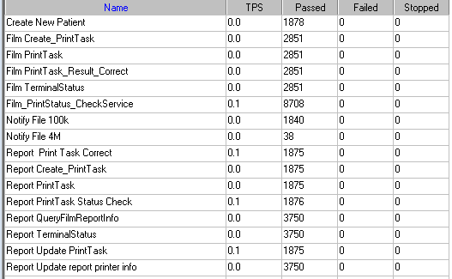

### Test Statistic Report of PS

|  |  |
| --- | --- |
| Analysis Summary | Period: 2018/8/12 9:07 - 2018/8/12 17:17 |

|  |  |
| --- | --- |
| **Scenario Name:** | E:\ECS\Performance\Script\208\ScenarioPUMA\_Reliability\_171.lrs |
| **Results in Session:** | c:\Users\Administrator\AppData\Local\Temp\res119\res119.lrr |
| **Duration:** | 8 hours, 9 minutes and 27 seconds. |

|  |
| --- |
| Statistics Summary |

|  |  |  |
| --- | --- | --- |
| [**Maximum Running Vusers:**](file:///\\10.184.129.235\puma\Team\Ralf\Performance\ClouldFilm%20Performance\report_2018_0812\VuserStateGraph) |  | 16 |
| [**Total Throughput (bytes):**](file:///\\10.184.129.235\puma\Team\Ralf\Performance\ClouldFilm%20Performance\report_2018_0812\Throughput) | [Show SLA Results](slarules:total_throughput) | 16,706,770 |
| [**Average Throughput (bytes/second):**](file:///\\10.184.129.235\puma\Team\Ralf\Performance\ClouldFilm%20Performance\report_2018_0812\Throughput) | [Show SLA Results](slarules:average_throughput) | 569 |
| [**Total Hits:**](file:///\\10.184.129.235\puma\Team\Ralf\Performance\ClouldFilm%20Performance\report_2018_0812\HitsperSecond) | [Show SLA Results](slarules:total_hits) | 17,261 |
| [**Average Hits per Second:**](file:///\\10.184.129.235\puma\Team\Ralf\Performance\ClouldFilm%20Performance\report_2018_0812\HitsperSecond) | [Show SLA Results](slarules:average_hits) | 0.588 | [**View HTTP Responses Summary**](file:///\\10.184.129.235\puma\Team\Ralf\Performance\ClouldFilm%20Performance\report_2018_0812\report_2018_0812.html#1) |
| [**Total Errors:**](file:///\\10.184.129.235\puma\Team\Ralf\Performance\ClouldFilm%20Performance\report_2018_0812\TotalErrorsPerSecond) | [Show SLA Results](slarules:errors_per_second) | 2 |  |

|  |  |  |
| --- | --- | --- |
| |  | | --- | | You can define SLA data using the [SLA configuration wizard](slaconfig:) | | You can analyze transaction behavior using the [Analyze Transaction mechanism](analyze:) | |

|  |
| --- |
| Transaction Summary |

|  |  |  |  |  |
| --- | --- | --- | --- | --- |
| [**Transactions:**](file:///\\10.184.129.235\puma\Team\Ralf\Performance\ClouldFilm%20Performance\report_2018_0812\TransactionSummary) | Total Passed: 44,494 | Total Failed: 0 | Total Stopped: 0 | [**Average Response Time**](file:///\\10.184.129.235\puma\Team\Ralf\Performance\ClouldFilm%20Performance\report_2018_0812\ResponseTime) |

|  |  |  |  |  |  |  |  |  |  |
| --- | --- | --- | --- | --- | --- | --- | --- | --- | --- |
| **Transaction Name** | **SLA Status** | **Minimum** | **Average** | **Maximum** | **Std. Deviation** | **90 Percent** | **Pass** | **Fail** | **Stop** |
| [Create New Patient](file:///\\10.184.129.235\puma\Team\Ralf\Performance\ClouldFilm%20Performance\report_2018_0812\ResponseTime0000(Create%20New%20Patient)0000) | [Show SLA Results](slarules:transaction_response_time_CreateNewPatient) | 0.078 | 0.188 | 7.289 | 0.272 | 0.328 | 1,878 | 0 | 0 |
| [Film Create\_PrintTask](file:///\\10.184.129.235\puma\Team\Ralf\Performance\ClouldFilm%20Performance\report_2018_0812\ResponseTime0000(Film%20Create_PrintTask)0000) | [Show SLA Results](slarules:transaction_response_time_FilmCreate_PrintTask) | 0.827 | 1.252 | 10.797 | 0.465 | 1.81 | 2,851 | 0 | 0 |
| [Film PrintTask](file:///\\10.184.129.235\puma\Team\Ralf\Performance\ClouldFilm%20Performance\report_2018_0812\ResponseTime0000(Film%20PrintTask)0000) | [Show SLA Results](slarules:transaction_response_time_FilmPrintTask) | 0.016 | 0.097 | 1.186 | 0.123 | 0.218 | 2,851 | 0 | 0 |
| [Film PrintTask\_Result\_Correct](file:///\\10.184.129.235\puma\Team\Ralf\Performance\ClouldFilm%20Performance\report_2018_0812\ResponseTime0000(Film%20PrintTask_Result_Correct)0000) | [Show SLA Results](slarules:transaction_response_time_FilmPrintTask_Result_Correct) | 0 | 0 | 0.016 | 0.001 | 0 | 2,851 | 0 | 0 |
| [Film TerminalStatus](file:///\\10.184.129.235\puma\Team\Ralf\Performance\ClouldFilm%20Performance\report_2018_0812\ResponseTime0000(Film%20TerminalStatus)0000) | [Show SLA Results](slarules:transaction_response_time_FilmTerminalStatus) | 0 | 0.08 | 4.867 | 0.148 | 0.187 | 2,851 | 0 | 0 |
| [Film\_PrintStatus\_CheckService](file:///\\10.184.129.235\puma\Team\Ralf\Performance\ClouldFilm%20Performance\report_2018_0812\ResponseTime0000(Film_PrintStatus_CheckService)0000) | [Show SLA Results](slarules:transaction_response_time_Film_PrintStatus_CheckService) | 0 | 0.086 | 8.002 | 0.187 | 0.218 | 8,708 | 0 | 0 |
| [Notify File 100k](file:///\\10.184.129.235\puma\Team\Ralf\Performance\ClouldFilm%20Performance\report_2018_0812\ResponseTime0000(Notify%20File%20100k)0000) | [Show SLA Results](slarules:transaction_response_time_NotifyFile100k) | 0.031 | 0.409 | 9.064 | 0.482 | 0.863 | 1,840 | 0 | 0 |
| [Notify File 4M](file:///\\10.184.129.235\puma\Team\Ralf\Performance\ClouldFilm%20Performance\report_2018_0812\ResponseTime0000(Notify%20File%204M)0000) | [Show SLA Results](slarules:transaction_response_time_NotifyFile4M) | 0.094 | 0.527 | 2.153 | 0.373 | 1.026 | 38 | 0 | 0 |
| [Report Print Task Correct](file:///\\10.184.129.235\puma\Team\Ralf\Performance\ClouldFilm%20Performance\report_2018_0812\ResponseTime0000(Report%20%20Print%20Task%20Correct)0000) | [Show SLA Results](slarules:transaction_response_time_ReportPrintTaskCorrect) | 0 | 0 | 0 | 0 | 0 | 1,875 | 0 | 0 |
| [Report Create\_PrintTask](file:///\\10.184.129.235\puma\Team\Ralf\Performance\ClouldFilm%20Performance\report_2018_0812\ResponseTime0000(Report%20Create_PrintTask)0000) | [Show SLA Results](slarules:transaction_response_time_ReportCreate_PrintTask) | 0.406 | 0.796 | 7.414 | 0.397 | 1.232 | 1,875 | 0 | 0 |
| [Report PrintTask](file:///\\10.184.129.235\puma\Team\Ralf\Performance\ClouldFilm%20Performance\report_2018_0812\ResponseTime0000(Report%20PrintTask)0000) | [Show SLA Results](slarules:transaction_response_time_ReportPrintTask) | 0.016 | 0.13 | 5.374 | 0.209 | 0.318 | 1,875 | 0 | 0 |
| [Report PrintTask Status Check](file:///\\10.184.129.235\puma\Team\Ralf\Performance\ClouldFilm%20Performance\report_2018_0812\ResponseTime0000(Report%20PrintTask%20Status%20Check)0000) | [Show SLA Results](slarules:transaction_response_time_ReportPrintTaskStatusCheck) | 0 | 0.093 | 9.032 | 0.287 | 0.212 | 1,876 | 0 | 0 |
| [Report QueryFilmReportInfo](file:///\\10.184.129.235\puma\Team\Ralf\Performance\ClouldFilm%20Performance\report_2018_0812\ResponseTime0000(Report%20QueryFilmReportInfo)0000) | [Show SLA Results](slarules:transaction_response_time_ReportQueryFilmReportInfo) | 0.499 | 0.902 | 18.169 | 0.513 | 1.364 | 3,750 | 0 | 0 |
| [Report TerminalStatus](file:///\\10.184.129.235\puma\Team\Ralf\Performance\ClouldFilm%20Performance\report_2018_0812\ResponseTime0000(Report%20TerminalStatus)0000) | [Show SLA Results](slarules:transaction_response_time_ReportTerminalStatus) | 0 | 0.078 | 6.412 | 0.169 | 0.196 | 3,750 | 0 | 0 |
| [Report Update PrintTask](file:///\\10.184.129.235\puma\Team\Ralf\Performance\ClouldFilm%20Performance\report_2018_0812\ResponseTime0000(Report%20Update%20PrintTask)0000) | [Show SLA Results](slarules:transaction_response_time_ReportUpdatePrintTask) | 0.016 | 0.159 | 11.99 | 0.345 | 0.359 | 1,875 | 0 | 0 |
| [Report Update report printer info](file:///\\10.184.129.235\puma\Team\Ralf\Performance\ClouldFilm%20Performance\report_2018_0812\ResponseTime0000(Report%20Update%20report%20printer%20info)0000) | [Show SLA Results](slarules:transaction_response_time_ReportUpdatereportprinterinfo) | 0 | 0.074 | 9.108 | 0.204 | 0.187 | 3,750 | 0 | 0 |

|  |  |  |  |  |  |  |
| --- | --- | --- | --- | --- | --- | --- |
| **Service Level Agreement Legend:** | \\10.184.129.235\puma\Team\Ralf\Performance\ClouldFilm Performance\report_2018_0812\led_ok.gif | Pass | \\10.184.129.235\puma\Team\Ralf\Performance\ClouldFilm Performance\report_2018_0812\led_error.gif | Fail | \\10.184.129.235\puma\Team\Ralf\Performance\ClouldFilm Performance\report_2018_0812\led_no_data.gif | No Data |

|  |
| --- |
| HTTP Responses Summary |

|  |  |  |
| --- | --- | --- |
| **HTTP Responses** | **Total** | **Per second** |
| [HTTP\_200](file:///\\10.184.129.235\puma\Team\Ralf\Performance\ClouldFilm%20Performance\report_2018_0812\HttpReturnCodes0001(HTTP_200)0001) | 17,261 | 0.588 |

Follow the summary report, we can see all the transactions has passed and transaction response time can accept.

### Transaction summary result of PS

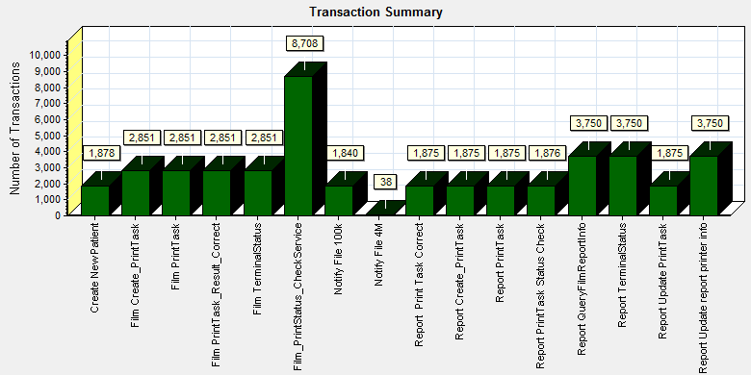

|  |  |  |  |  |  |  |
| --- | --- | --- | --- | --- | --- | --- |
| |  |  |  | | --- | --- | --- | | Color | Scale | Measurement | |  | 1 | Pass | |
|  |
|  |
|  |
|  |
|  |

Transaction Summary

We can see that there is no transaction failed during the testing works.

### Transaction response time result of PS

We can get the transaction response time information from the figure as follow:

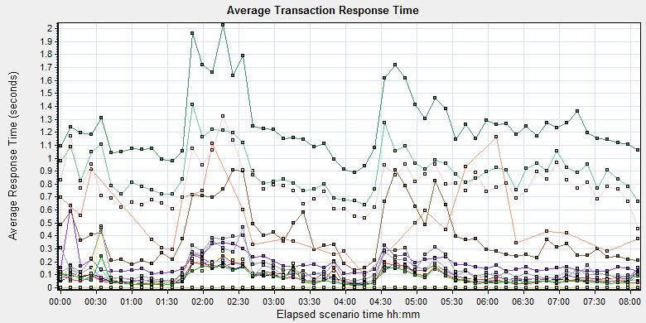

|  |  |  |  |  |  |  |  |  |  |  |  |  |  |  |  |  |  |  |  |  |  |  |  |  |  |  |  |  |  |  |  |  |  |  |  |  |  |  |  |  |  |  |  |  |  |  |  |  |  |  |  |  |  |  |  |  |  |  |  |  |  |  |  |  |  |  |  |  |  |  |  |  |  |  |  |  |  |  |  |  |  |  |  |  |  |  |  |  |  |  |  |  |  |  |  |  |  |  |  |  |  |  |  |  |  |  |  |  |  |  |  |  |  |  |  |  |  |  |  |
| --- | --- | --- | --- | --- | --- | --- | --- | --- | --- | --- | --- | --- | --- | --- | --- | --- | --- | --- | --- | --- | --- | --- | --- | --- | --- | --- | --- | --- | --- | --- | --- | --- | --- | --- | --- | --- | --- | --- | --- | --- | --- | --- | --- | --- | --- | --- | --- | --- | --- | --- | --- | --- | --- | --- | --- | --- | --- | --- | --- | --- | --- | --- | --- | --- | --- | --- | --- | --- | --- | --- | --- | --- | --- | --- | --- | --- | --- | --- | --- | --- | --- | --- | --- | --- | --- | --- | --- | --- | --- | --- | --- | --- | --- | --- | --- | --- | --- | --- | --- | --- | --- | --- | --- | --- | --- | --- | --- | --- | --- | --- | --- | --- | --- | --- | --- | --- | --- | --- | --- |
| |  |  |  |  |  |  |  | | --- | --- | --- | --- | --- | --- | --- | | **Color** | **Scale** | **Measurement** | **Graph's Minimum** | **Graph's Average** | **Graph's Maximum** | **Graph's Median** | |  | 1 | Create New Patient | 0.108 | 0.187 | 0.63 | 0.158 | |  | 1 | Film Create\_PrintTask | 0.888 | 1.253 | 2.026 | 1.194 | |  | 1 | Film PrintTask | 0.031 | 0.099 | 0.253 | 0.077 | |  | 1 | Film PrintTask\_Result\_Correct | 0 | 0 | 0.001 | 0 | |  | 1 | Film TerminalStatus | 0.022 | 0.081 | 0.206 | 0.064 | |  | 1 | Film\_PrintStatus\_CheckService | 0.019 | 0.083 | 0.209 | 0.058 | |  | 1 | Notify File 100k | 0.137 | 0.407 | 0.911 | 0.358 | |  | 1 | Notify File 4M | 0.094 | 0.519 | 1.162 | 0.432 | |  | 1 | Report Print Task Correct | 0 | 0 | 0 | 0 | |  | 1 | Report Create\_PrintTask | 0.456 | 0.793 | 1.326 | 0.773 | |  | 1 | Report PrintTask | 0.033 | 0.131 | 0.468 | 0.103 | |  | 1 | Report PrintTask Status Check | 0.021 | 0.093 | 0.474 | 0.063 | |  | 1 | Report QueryFilmReportInfo | 0.638 | 0.9 | 1.414 | 0.873 | |  | 1 | Report TerminalStatus | 0.017 | 0.078 | 0.193 | 0.056 | |  | 1 | Report Update PrintTask | 0.055 | 0.159 | 0.459 | 0.116 | |  | 1 | Report Update report printer info | 0.018 | 0.075 | 0.24 | 0.054 | |
|  |
|  |
|  |
|  |
|  |

|  |
| --- |
|  |
|  |

Transaction response time

This figure information shows all transaction response time. We can analysis that there are no transaction response time more than 3 seconds. It`s good performance for our system.

## Test result of Web service

### Test result of web transactions

After the performance testing works, the transactions result of we module as follow:

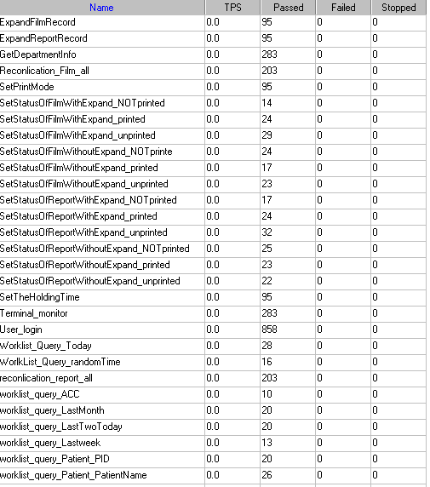

Follow the figure, we can see that there is no transactions failed.

### Test Statistic Report of Web

|  |  |
| --- | --- |
| Analysis Summary | Period: 12/08/2018 09:33:23 - 12/08/2018 15:37:40 |

|  |  |
| --- | --- |
| **Scenario Name:** | D:\Performance\ScenarioPUMA\_Reliability\_171.lrs |
| **Results in Session:** | c:\Users\administrator\appdata\local\temp\res1190\res1190.lrr |
| **Duration:** | 6 hours, 4 minutes and 17 seconds. |

|  |
| --- |
| Statistics Summary |

|  |  |  |  |  |
| --- | --- | --- | --- | --- |
| [**Maximum Running Vusers:**](file:///D:\CloudFilm_2018_0812\Report\Report0.html) | | | | 5 |
| [**Total Throughput (bytes):**](file:///D:\CloudFilm_2018_0812\Report\Report2.html) | | | 226,980,963 | | |
| [**Average Throughput (bytes/second):**](file:///D:\CloudFilm_2018_0812\Report\Report2.html) | | | | 10,384 |
|  | | | |  |
|  | | | |  |
|  | | | |  |
| [**Total Hits:**](file:///D:\CloudFilm_2018_0812\Report\Report1.html) | | | | 20,836 |
|  | | | |  |
|  | | | |  |
| [**Average Hits per Second:**](file:///D:\CloudFilm_2018_0812\Report\Report1.html) | | | | 0.953 |  | |
|  | | | |  |  | |
|  | | | |  |  | |
|  | | | |  |  | |
| Transaction Summary |

|  |  |  |  |  |
| --- | --- | --- | --- | --- |
| [**Transactions:**](file:///D:\CloudFilm_2018_0812\Report\Report3.html) | Total Passed: 2,637 | Total Failed: 0 | Total Stopped: 0 | [**Average Response Time**](file:///D:\CloudFilm_2018_0812\Report\Report4.html) |

|  |  |  |  |
| --- | --- | --- | --- |
|  | **Pass** | **Fail** | **Stop** |
| Total | 2,637 | 0 | 0 |

|  |  |  |  |  |  |  |  |  |
| --- | --- | --- | --- | --- | --- | --- | --- | --- |
| **Transaction Name** | **Minimum** | **Average** | **Maximum** | **Std. Deviation** | **90 Percent** | **Pass** | **Fail** | **Stop** |
| ExpandFilmRecord | 0.039 | 1.636 | 9.702 | 2.061 | 4.59 | 95 | 0 | 0 |
| ExpandReportRecord | 0.006 | 0.017 | 0.194 | 0.027 | 0.027 | 95 | 0 | 0 |
| GetDepartmentInfo | 0.005 | 0.015 | 0.35 | 0.032 | 0.018 | 283 | 0 | 0 |
| Reconlication\_Film\_all | 0.162 | 0.488 | 4.097 | 0.755 | 0.833 | 203 | 0 | 0 |
| reconlication\_report\_all | 0.026 | 0.208 | 3.47 | 0.553 | 0.295 | 203 | 0 | 0 |
| SetPrintMode | 0.026 | 0.931 | 3.892 | 1.344 | 3.338 | 95 | 0 | 0 |
| SetStatusOfFilmWithExpand\_NOTprinted | 0.08 | 2.396 | 7.782 | 2.219 | 5.492 | 14 | 0 | 0 |
| SetStatusOfFilmWithExpand\_printed | 0.1 | 2.833 | 8.503 | 2.932 | 7.124 | 24 | 0 | 0 |
| SetStatusOfFilmWithExpand\_unprinted | 0.082 | 3.186 | 13.433 | 2.968 | 5.791 | 29 | 0 | 0 |
| SetStatusOfFilmWithoutExpand\_NOTprinte | 0.04 | 0.662 | 3.324 | 1.024 | 3.193 | 24 | 0 | 0 |
| SetStatusOfFilmWithoutExpand\_printed | 0.045 | 1.22 | 5.011 | 1.606 | 3.369 | 17 | 0 | 0 |
| SetStatusOfFilmWithoutExpand\_unprinted | 0.052 | 0.906 | 3.501 | 1.275 | 3.244 | 23 | 0 | 0 |
| SetStatusOfReportWithExpand\_NOTprinted | 0.041 | 0.989 | 4.447 | 1.494 | 3.54 | 17 | 0 | 0 |
| SetStatusOfReportWithExpand\_printed | 0.038 | 0.931 | 3.613 | 1.388 | 3.214 | 24 | 0 | 0 |
| SetStatusOfReportWithExpand\_unprinted | 0.039 | 0.769 | 3.68 | 1.299 | 3.284 | 32 | 0 | 0 |
| SetStatusOfReportWithoutExpand\_NOTprinted | 0.049 | 1.372 | 4.112 | 1.564 | 3.572 | 25 | 0 | 0 |
| SetStatusOfReportWithoutExpand\_printed | 0.04 | 1.212 | 4.621 | 1.522 | 3.372 | 23 | 0 | 0 |
| SetStatusOfReportWithoutExpand\_unprinted | 0.048 | 1.059 | 3.992 | 1.484 | 3.373 | 22 | 0 | 0 |
| SetTheHoldingTime | 0.023 | 1.033 | 3.762 | 1.478 | 3.353 | 95 | 0 | 0 |
| Terminal\_monitor | 0.097 | 0.242 | 2.258 | 0.286 | 0.479 | 283 | 0 | 0 |
| User\_login | 0.169 | 0.498 | 4.516 | 0.494 | 1.063 | 858 | 0 | 0 |
| worklist\_query\_ACC | 0.011 | 0.023 | 0.063 | 0.016 | 0.037 | 10 | 0 | 0 |
| worklist\_query\_LastMonth | 0.037 | 0.089 | 0.259 | 0.063 | 0.212 | 20 | 0 | 0 |
| worklist\_query\_LastTwoToday | 0.013 | 0.061 | 0.218 | 0.057 | 0.128 | 20 | 0 | 0 |
| worklist\_query\_Lastweek | 0.04 | 0.099 | 0.513 | 0.127 | 0.208 | 13 | 0 | 0 |
| worklist\_query\_Patient\_PatientName | 0.014 | 0.037 | 0.11 | 0.028 | 0.084 | 26 | 0 | 0 |
| worklist\_query\_Patient\_PID | 0.014 | 0.057 | 0.396 | 0.09 | 0.091 | 20 | 0 | 0 |
| Worklist\_Query\_Today | 0.02 | 0.174 | 3.171 | 0.582 | 0.23 | 28 | 0 | 0 |
| WorlkList\_Query\_randomTime | 0.033 | 0.07 | 0.283 | 0.057 | 0.093 | 16 | 0 | 0 |

|  |  |  |  |  |  |  |
| --- | --- | --- | --- | --- | --- | --- |
| **Service Level Agreement Legend:** | D:\CloudFilm_2018_0812\Report\led_ok.gif | Pass | D:\CloudFilm_2018_0812\Report\led_error.gif | Fail | D:\CloudFilm_2018_0812\Report\led_no_data.gif | No Data |

|  |
| --- |
| HTTP Responses Summary |

|  |  |  |
| --- | --- | --- |
| **HTTP Responses** | **Total** | **Per second** |
| HTTP\_200 | 19,978 | 0.914 |
| HTTP\_302 | 858 | 0.039 |

Follow the summary report, we can see all the transactions has passed and transaction response time can accept.

### Transaction summary result of Web

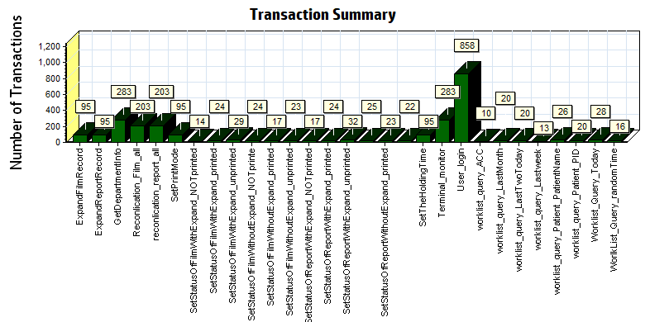

|  |  |  |  |  |  |  |
| --- | --- | --- | --- | --- | --- | --- |
| |  |  |  | | --- | --- | --- | | Color | Scale | Measurement | |  | 1 | Pass | |
|  |
|  |
|  |
|  |
|  |

Transaction Summary

We can see that there is no transaction failed during the testing works.

### Transaction response time result of Web

We can get the transaction response time information from the figure as follow:

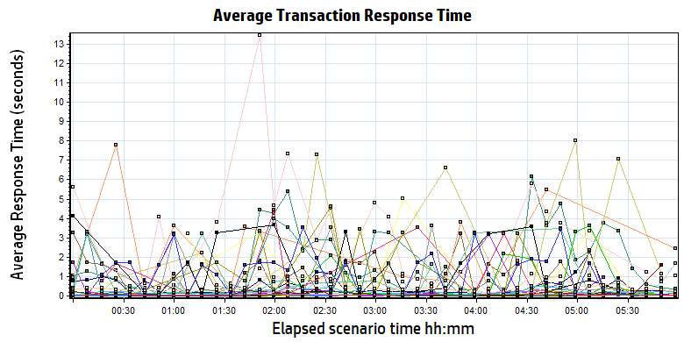

|  |  |  |  |  |  |
| --- | --- | --- | --- | --- | --- |
| **Color** | **Scale** | **Measurement** | **Minimum** | **Average** | **Maximum** |
|  | 1 | ExpandFilmRecord | 0.039 | 1.636 | 9.702 |
|  | 1 | ExpandReportRecord | 0.006 | 0.017 | 0.194 |
|  | 1 | GetDepartmentInfo | 0.005 | 0.015 | 0.350 |
|  | 1 | Reconlication\_Film\_all | 0.162 | 0.488 | 4.097 |
|  | 1 | reconlication\_report\_all | 0.026 | 0.208 | 3.470 |
|  | 1 | SetPrintMode | 0.026 | 0.931 | 3.892 |
|  | 1 | SetStatusOfFilmWithExpand\_NOTprinted | 0.080 | 2.396 | 7.782 |
|  | 1 | SetStatusOfFilmWithExpand\_printed | 0.100 | 2.833 | 8.503 |
|  | 1 | SetStatusOfFilmWithExpand\_unprinted | 0.082 | 3.186 | 13.433 |
|  | 1 | SetStatusOfFilmWithoutExpand\_NOTprinte | 0.040 | 0.662 | 3.324 |
|  | 1 | SetStatusOfFilmWithoutExpand\_printed | 0.045 | 1.220 | 5.011 |
|  | 1 | SetStatusOfFilmWithoutExpand\_unprinted | 0.052 | 0.906 | 3.501 |
|  | 1 | SetStatusOfReportWithExpand\_NOTprinted | 0.041 | 0.989 | 4.447 |
|  | 1 | SetStatusOfReportWithExpand\_printed | 0.038 | 0.931 | 3.613 |
|  | 1 | SetStatusOfReportWithExpand\_unprinted | 0.039 | 0.769 | 3.680 |
|  | 1 | SetStatusOfReportWithoutExpand\_NOTprinted | 0.049 | 1.372 | 4.112 |
|  | 1 | SetStatusOfReportWithoutExpand\_printed | 0.040 | 1.212 | 4.621 |
|  | 1 | SetStatusOfReportWithoutExpand\_unprinted | 0.048 | 1.059 | 3.992 |
|  | 1 | SetTheHoldingTime | 0.023 | 1.033 | 3.762 |
|  | 1 | Terminal\_monitor | 0.097 | 0.242 | 2.258 |
|  | 1 | User\_login | 0.169 | 0.498 | 4.516 |
|  | 1 | worklist\_query\_ACC | 0.011 | 0.023 | 0.063 |
|  | 1 | worklist\_query\_LastMonth | 0.037 | 0.089 | 0.259 |
|  | 1 | worklist\_query\_LastTwoToday | 0.013 | 0.061 | 0.218 |
|  | 1 | worklist\_query\_Lastweek | 0.040 | 0.099 | 0.513 |
|  | 1 | worklist\_query\_Patient\_PatientName | 0.014 | 0.037 | 0.110 |
|  | 1 | worklist\_query\_Patient\_PID | 0.014 | 0.057 | 0.396 |
|  | 1 | Worklist\_Query\_Today | 0.020 | 0.174 | 3.171 |
|  | 1 | WorlkList\_Query\_randomTime | 0.033 | 0.070 | 0.283 |

Transaction response time

Follow the figure: we can see that the transaction average response time is less than 4 seconds. But some transactions response time is not smoothly. We should monitor that and try to fix the issues.

|  |
| --- |
|  |
|  |
|  |
|  |
|  |

|  |
| --- |
|  |
|  |

## Performance bottleneck analysis

### Hardware usage analysis

During the testing work, we use the test tool to monitor the server hardware usage include the CPU, Memory, hard disk and etc.

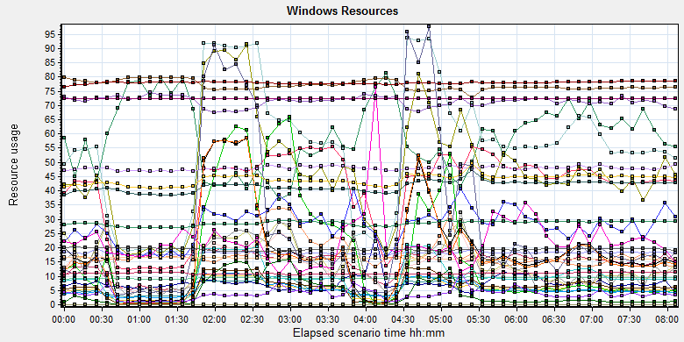

|  |  |  |  |  |  |  |  |  |  |  |  |  |  |  |  |  |  |  |  |  |  |  |  |  |  |  |  |  |  |  |  |  |  |  |  |  |  |  |  |  |  |  |  |  |  |  |  |  |  |  |  |  |  |  |  |  |  |  |  |  |  |  |  |  |  |  |  |  |  |  |  |  |  |  |  |  |  |  |  |  |  |  |  |  |  |  |  |  |  |  |  |  |  |  |  |  |  |  |  |  |  |  |  |  |  |  |  |  |  |  |  |  |  |  |  |  |  |  |  |  |  |  |  |  |  |  |  |  |  |  |  |  |  |  |  |  |  |  |  |  |  |  |  |  |  |  |  |  |  |  |  |  |  |  |  |  |  |  |  |  |  |  |  |  |  |  |  |  |  |  |  |  |  |  |  |  |  |  |  |  |  |  |  |  |  |  |  |  |  |  |  |  |  |  |  |  |  |  |  |  |  |  |  |  |  |  |  |  |  |  |  |  |  |  |  |  |  |  |  |  |  |  |  |  |  |  |  |  |  |  |  |  |  |  |  |  |  |  |  |  |  |  |  |  |  |  |  |  |  |  |  |  |  |  |  |  |  |  |  |  |  |  |  |  |  |  |  |  |  |  |  |  |  |  |  |  |  |  |  |  |
| --- | --- | --- | --- | --- | --- | --- | --- | --- | --- | --- | --- | --- | --- | --- | --- | --- | --- | --- | --- | --- | --- | --- | --- | --- | --- | --- | --- | --- | --- | --- | --- | --- | --- | --- | --- | --- | --- | --- | --- | --- | --- | --- | --- | --- | --- | --- | --- | --- | --- | --- | --- | --- | --- | --- | --- | --- | --- | --- | --- | --- | --- | --- | --- | --- | --- | --- | --- | --- | --- | --- | --- | --- | --- | --- | --- | --- | --- | --- | --- | --- | --- | --- | --- | --- | --- | --- | --- | --- | --- | --- | --- | --- | --- | --- | --- | --- | --- | --- | --- | --- | --- | --- | --- | --- | --- | --- | --- | --- | --- | --- | --- | --- | --- | --- | --- | --- | --- | --- | --- | --- | --- | --- | --- | --- | --- | --- | --- | --- | --- | --- | --- | --- | --- | --- | --- | --- | --- | --- | --- | --- | --- | --- | --- | --- | --- | --- | --- | --- | --- | --- | --- | --- | --- | --- | --- | --- | --- | --- | --- | --- | --- | --- | --- | --- | --- | --- | --- | --- | --- | --- | --- | --- | --- | --- | --- | --- | --- | --- | --- | --- | --- | --- | --- | --- | --- | --- | --- | --- | --- | --- | --- | --- | --- | --- | --- | --- | --- | --- | --- | --- | --- | --- | --- | --- | --- | --- | --- | --- | --- | --- | --- | --- | --- | --- | --- | --- | --- | --- | --- | --- | --- | --- | --- | --- | --- | --- | --- | --- | --- | --- | --- | --- | --- | --- | --- | --- | --- | --- | --- | --- | --- | --- | --- | --- | --- | --- | --- | --- | --- | --- | --- | --- | --- | --- | --- | --- | --- | --- | --- | --- | --- | --- | --- | --- | --- | --- | --- | --- | --- | --- | --- | --- | --- | --- | --- | --- | --- | --- | --- | --- |
| |  |  |  |  |  |  |  | | --- | --- | --- | --- | --- | --- | --- | | **Color** | **Scale** | **Measurement** | **Minimum** | **Average** | **Maximum** | **Std. Deviation** | |  | 0.1 | % Disk Time (PhysicalDisk \_Total):10.184.129.108 | 1.943 | 144.704 | 13112.083 | 271.074 | |  | 1 | % Idle Time (PhysicalDisk \_Total):10.184.129.108 | 0 | 59.179 | 98.59 | 23.017 | |  | 100 | % Interrupt Time (Processor \_Total):10.184.129.108 | 0 | 0.143 | 1.128 | 0.134 | |  | 1 | % Privileged Time (Processor \_Total):10.184.129.108 | 0 | 5.556 | 17.444 | 3.418 | |  | 10 | % Processor Time (Process CloudDataUploadService):10.184.129.108 | 0 | 0.752 | 14.508 | 1.384 | |  | 1 | % Processor Time (Processor \_Total):10.184.129.108 | 0.781 | 55.217 | 100 | 26.888 | |  | 0.01 | Available MBytes (Memory):10.184.129.108 | 6973 | 7704.322 | 8213 | 172.525 | |  | 0.0001 | Avg. Disk Bytes/Transfer (PhysicalDisk \_Total):10.184.129.108 | 972.8 | 179682.53 | 1249028.655 | 157075.381 | |  | 10 | Avg. Disk Queue Length (PhysicalDisk \_Total):10.184.129.108 | 0.019 | 1.447 | 131.121 | 2.711 | |  | 10 | Avg. Disk Write Queue Length (PhysicalDisk \_Total):10.184.129.108 | 0.019 | 1.252 | 22.579 | 1.338 | |  | 0.001 | Bytes Total/sec (Server):10.184.129.108 | 14471.872 | 18151.065 | 260978.525 | 2498.784 | |  | 1E-07 | Cache Bytes (Memory):10.184.129.108 | 269893632 | 286209815.961 | 308727808 | 8582073.467 | |  | 1E-09 | Committed Bytes (Memory):10.184.129.108 | 8835493888 | 9398247526.568 | 10406977536 | 217787863.82 | |  | 0.001 | Context Switches/sec (System):10.184.129.108 | 2642.54 | 40765.966 | 108561.299 | 22466.931 | |  | 10 | Current Disk Queue Length (PhysicalDisk \_Total):10.184.129.108 | 0 | 1.426 | 132 | 3.626 | |  | 1E-05 | Disk Read Bytes/sec (PhysicalDisk \_Total):10.184.129.108 | 0 | 1799025.922 | 71561318.841 | 3207552.076 | |  | 1 | Disk Reads/sec (PhysicalDisk \_Total):10.184.129.108 | 0 | 19.102 | 707.705 | 27.274 | |  | 1 | Disk Transfers/sec (PhysicalDisk \_Total):10.184.129.108 | 2.325 | 46.907 | 725.639 | 33.724 | |  | 1E-06 | Disk Write Bytes/sec (PhysicalDisk \_Total):10.184.129.108 | 2551.376 | 5571317.968 | 31155380.416 | 4575272.12 | |  | 1 | Disk Writes/sec (PhysicalDisk \_Total):10.184.129.108 | 1.329 | 27.805 | 253.988 | 15.736 | |  | 0.001 | File Data Operations/sec (System):10.184.129.108 | 273.011 | 9351.431 | 33335.757 | 7679.698 | |  | 1E-05 | Free Megabytes (LogicalDisk \_Total):10.184.129.108 | 1586554 | 1626565.694 | 1665603 | 23994.447 | |  | 0.001 | Interrupts/sec (Processor \_Total):10.184.129.108 | 540.718 | 5630.306 | 31290.07 | 4445.903 | |  | 0.0001 | Page Faults/sec (Memory):10.184.129.108 | 73.071 | 62247.542 | 196282.521 | 45635.606 | |  | 0.1 | Page Faults/sec (Process CloudDataUploadService):10.184.129.108 | 0 | 223.618 | 6395.67 | 485.312 | |  | 1E-06 | Page File Bytes (Process CloudDataUploadService):10.184.129.108 | 42242048 | 47898709.754 | 83550208 | 1904724.8 | |  | 1 | Page Reads/sec (Memory):10.184.129.108 | 0 | 18.315 | 723.978 | 27.247 | |  | 0.01 | Pages/sec (Memory):10.184.129.108 | 0 | 416.062 | 5295.336 | 690.214 | |  | 1E-06 | Pool Nonpaged Bytes (Memory):10.184.129.108 | 75587584 | 77938021.307 | 80072704 | 488807.469 | |  | 0.0001 | Pool Nonpaged Bytes (Server):10.184.129.108 | 630463 | 714018.259 | 790207 | 24692.478 | |  | 1E-07 | Pool Paged Bytes (Memory):10.184.129.108 | 187564032 | 194669019.429 | 203177984 | 3612893.68 | |  | 0.001 | Pool Paged Bytes (Server):10.184.129.108 | 72245 | 72245 | 72245 | 0 | |  | 1 | Pool Paged Failures (Server):10.184.129.108 | 0 | 0 | 0 | 0 | |  | 1E-08 | Private Bytes (Process \_Total):10.184.129.108 | 3653181440 | 4158895589.097 | 5109260288 | 192712363.521 | |  | 10 | Processor Queue Length (System):10.184.129.108 | 0 | 2.728 | 51 | 5.205 | |  | 1 | Split IO/Sec (PhysicalDisk \_Total):10.184.129.108 | 0 | 3.776 | 220.744 | 8.469 | |  | 1E-07 | System Cache Resident Bytes (Memory):10.184.129.108 | 269893632 | 286210413.714 | 308727808 | 8582120.015 | |  | 0.001 | Threads (Objects):10.184.129.108 | 10441 | 11017.358 | 11623 | 283.241 | |  | 1E-08 | Working Set (Process \_Total):10.184.129.108 | 3924684800 | 4395821813.071 | 5384916992 | 193010110.831 | |
|  |
|  |
| \\10.184.129.235\puma\Team\Ralf\Performance\ClouldFilm Performance\report_2018_0812\Report\dot_trans.gif |
|  |
| |  | | --- | | Description: Displays a summary of the System Resources usage for each Windows based host. | |  | |

Follow this information we can get that:

The CPU resource has the bottleneck. The average process time is 55%, but if the system has the upload task, the usage will grow up and value is more than 80%.

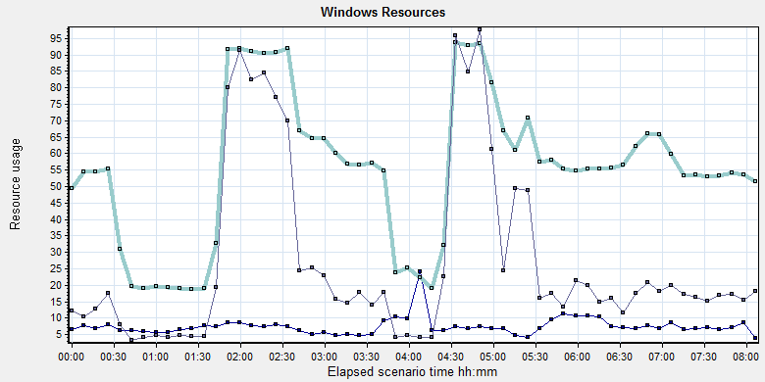

|  |  |  |  |  |  |
| --- | --- | --- | --- | --- | --- |
| **Color** | **Scale** | **Measurement** | **Minimum** | **Average** | **Maximum** |
|  | 10 | % Processor Time (Process CloudDataUploadService):10.184.129.108 | 0 | 0.752 | 14.508 |
|  | 1 | % Processor Time (Processor \_Total):10.184.129.108 | 0.781 | 55.217 | 100 |
|  | 10 | Processor Queue Length (System):10.184.129.108 | 0 | 2.728 | 51 |

If the system exist a lot image need to upload, the system processor usage time will more than 80% and queue length will be 8-9. The CPU processor queue is less than the threshold value 12 (6\*2). But the process time is more than the threshold 80%. The CPU resource will used to zip the DICOM files and upload operations.

The memory resource do not has the bottleneck. There are enough resource for system to use.

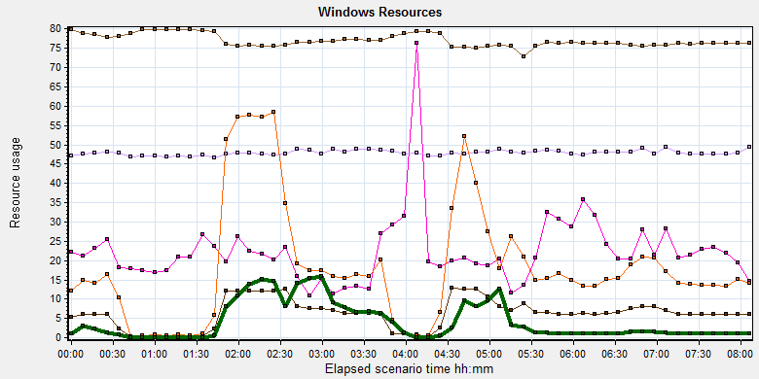

|  |  |  |  |  |  |  |
| --- | --- | --- | --- | --- | --- | --- |
| Color | Scale | Measurement | Minimum | Average | Maximum | Std. Deviation |
|  | 0.01 | Available MBytes (Memory):10.184.129.108 | 6973 | 7704.322 | 8213 | 172.525 |
|  | 0.0001 | Page Faults/sec (Memory):10.184.129.108 | 73.071 | 62247.542 | 196282.521 | 45635.606 |
|  | 0.1 | Page Faults/sec (Process CloudDataUploadService):10.184.129.108 | 0 | 223.618 | 6395.67 | 485.312 |
|  | 1E-06 | Page File Bytes (Process CloudDataUploadService):10.184.129.108 | 42242048 | 47898709.754 | 83550208 | 1904724.8 |
|  | 1 | Page Reads/sec (Memory):10.184.129.108 | 0 | 18.315 | 723.978 | 27.247 |
|  | 0.01 | Pages/sec (Memory):10.184.129.108 | 0 | 416.062 | 5295.336 | 690.214 |

The disk has stress during performance testing works:

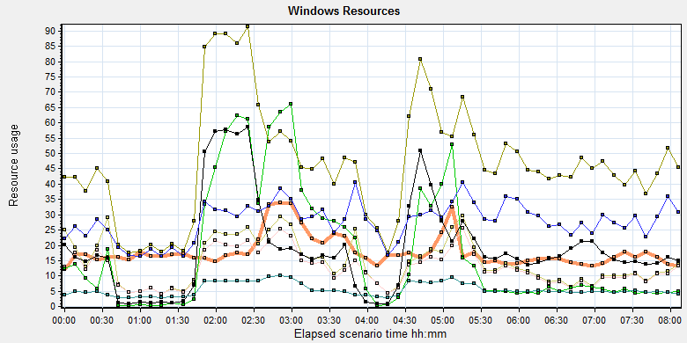

|  |  |  |  |  |  |  |  |  |  |  |  |  |  |  |  |  |  |  |  |  |  |  |  |  |  |  |  |  |  |  |  |  |  |  |  |  |  |  |  |  |  |  |  |  |  |  |  |  |  |  |  |  |  |  |  |  |  |  |  |  |  |  |  |
| --- | --- | --- | --- | --- | --- | --- | --- | --- | --- | --- | --- | --- | --- | --- | --- | --- | --- | --- | --- | --- | --- | --- | --- | --- | --- | --- | --- | --- | --- | --- | --- | --- | --- | --- | --- | --- | --- | --- | --- | --- | --- | --- | --- | --- | --- | --- | --- | --- | --- | --- | --- | --- | --- | --- | --- | --- | --- | --- | --- | --- | --- | --- | --- |
| |  |  |  |  |  |  |  | | --- | --- | --- | --- | --- | --- | --- | | Color | Scale | Measurement | Minimum | Average | Maximum | Std. Deviation | |  | 0.0001 | Avg. Disk Bytes/Transfer (PhysicalDisk \_Total):10.184.129.108 | 972.8 | 179682.53 | 1249028.655 | 157075.381 | |  | 10 | Avg. Disk Queue Length (PhysicalDisk \_Total):10.184.129.108 | 0.019 | 1.447 | 131.121 | 2.711 | |  | 10 | Avg. Disk Write Queue Length (PhysicalDisk \_Total):10.184.129.108 | 0.019 | 1.252 | 22.579 | 1.338 | |  | 1E-05 | Disk Read Bytes/sec (PhysicalDisk \_Total):10.184.129.108 | 0 | 1799025.922 | 71561318.841 | 3207552.076 | |  | 1 | Disk Reads/sec (PhysicalDisk \_Total):10.184.129.108 | 0 | 19.102 | 707.705 | 27.274 | |  | 1 | Disk Transfers/sec (PhysicalDisk \_Total):10.184.129.108 | 2.325 | 46.907 | 725.639 | 33.724 | |  | 1E-06 | Disk Write Bytes/sec (PhysicalDisk \_Total):10.184.129.108 | 2551.376 | 5571317.968 | 31155380.416 | 4575272.12 | |  | 1 | Disk Writes/sec (PhysicalDisk \_Total):10.184.129.108 | 1.329 | 27.805 | 253.988 | 15.736 | |
|  |
|  |
| Follow the figure: we can see that there are many disk tasks exist in the system during the testing work. The thought for disk is accepted, the stress is too many queue need to process for disk. |

### SQL Server resource usage analysis

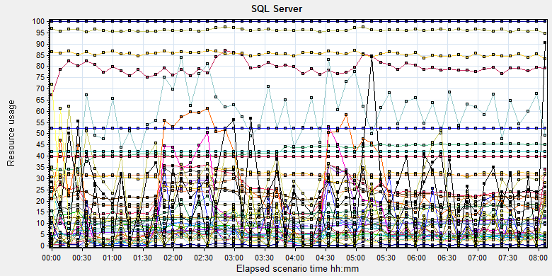

|  |  |  |  |  |  |  |  |  |  |  |  |  |  |  |  |  |  |  |  |  |  |  |  |  |  |  |  |  |  |  |  |  |  |  |  |  |  |  |  |  |  |  |  |  |  |  |  |  |  |  |  |  |  |  |  |  |  |  |  |  |  |  |  |  |  |  |  |  |  |  |  |  |  |  |  |  |  |  |  |  |  |  |  |  |  |  |  |  |  |  |  |  |  |  |  |  |  |  |  |  |  |  |  |  |  |  |  |  |  |  |  |  |  |  |  |  |  |  |  |  |  |  |  |  |  |  |  |  |  |  |  |  |  |  |  |  |  |  |  |  |  |  |  |  |  |  |  |  |  |  |  |  |  |  |  |  |  |  |  |  |  |  |  |  |  |  |  |  |  |  |  |  |  |  |  |  |  |  |  |  |  |  |  |  |  |  |  |  |  |  |  |  |  |  |  |  |  |  |  |  |  |  |  |  |  |  |  |  |  |  |  |  |  |  |  |  |  |  |  |  |  |  |  |  |  |  |  |  |  |  |  |  |  |  |  |  |  |  |  |  |  |  |  |  |  |  |  |  |  |  |  |  |  |  |  |  |  |  |  |  |  |  |  |  |  |  |  |  |  |  |  |  |  |  |  |  |  |  |  |  |  |  |  |  |  |  |  |  |  |  |  |  |  |  |  |  |  |  |  |  |  |  |  |  |  |  |  |  |  |  |  |  |  |  |  |  |  |  |  |  |  |  |  |  |  |  |  |  |  |  |  |  |  |  |  |  |  |  |  |  |  |  |  |  |  |  |  |  |
| --- | --- | --- | --- | --- | --- | --- | --- | --- | --- | --- | --- | --- | --- | --- | --- | --- | --- | --- | --- | --- | --- | --- | --- | --- | --- | --- | --- | --- | --- | --- | --- | --- | --- | --- | --- | --- | --- | --- | --- | --- | --- | --- | --- | --- | --- | --- | --- | --- | --- | --- | --- | --- | --- | --- | --- | --- | --- | --- | --- | --- | --- | --- | --- | --- | --- | --- | --- | --- | --- | --- | --- | --- | --- | --- | --- | --- | --- | --- | --- | --- | --- | --- | --- | --- | --- | --- | --- | --- | --- | --- | --- | --- | --- | --- | --- | --- | --- | --- | --- | --- | --- | --- | --- | --- | --- | --- | --- | --- | --- | --- | --- | --- | --- | --- | --- | --- | --- | --- | --- | --- | --- | --- | --- | --- | --- | --- | --- | --- | --- | --- | --- | --- | --- | --- | --- | --- | --- | --- | --- | --- | --- | --- | --- | --- | --- | --- | --- | --- | --- | --- | --- | --- | --- | --- | --- | --- | --- | --- | --- | --- | --- | --- | --- | --- | --- | --- | --- | --- | --- | --- | --- | --- | --- | --- | --- | --- | --- | --- | --- | --- | --- | --- | --- | --- | --- | --- | --- | --- | --- | --- | --- | --- | --- | --- | --- | --- | --- | --- | --- | --- | --- | --- | --- | --- | --- | --- | --- | --- | --- | --- | --- | --- | --- | --- | --- | --- | --- | --- | --- | --- | --- | --- | --- | --- | --- | --- | --- | --- | --- | --- | --- | --- | --- | --- | --- | --- | --- | --- | --- | --- | --- | --- | --- | --- | --- | --- | --- | --- | --- | --- | --- | --- | --- | --- | --- | --- | --- | --- | --- | --- | --- | --- | --- | --- | --- | --- | --- | --- | --- | --- | --- | --- | --- | --- | --- | --- | --- | --- | --- | --- | --- | --- | --- | --- | --- | --- | --- | --- | --- | --- | --- | --- | --- | --- | --- | --- | --- | --- | --- | --- | --- | --- | --- | --- | --- | --- | --- | --- | --- | --- | --- | --- | --- | --- | --- | --- | --- | --- | --- | --- | --- | --- | --- | --- | --- | --- | --- | --- | --- | --- | --- | --- | --- | --- | --- | --- | --- | --- | --- | --- | --- | --- | --- | --- | --- | --- | --- | --- |
| |  |  |  |  |  |  | | --- | --- | --- | --- | --- | --- | | Color | Scale | Measurement | Minimum | Average | Maximum | |  | 1 | Average Latch Wait Time (ms) (MSSQL$GCPACSWS|Latches):10.184.129.108 | 0.071 | 9.822 | 339.12 | |  | 1 | Buffer cache hit ratio (MSSQL$GCPACSWS|Buffer Manager):10.184.129.108 | 74.508 | 99.997 | 100 | |  | 1 | Cache Hit Ratio (MSSQL$GCPACSWS|Catalog Metadata \_Total):10.184.129.108 | 9.704 | 14.292 | 18.79 | |  | 1 | Cache Hit Ratio (MSSQL$GCPACSWS|Cursor Manager by Type \_Total):10.184.129.108 | 52.86 | 79.243 | 91.066 | |  | 1 | Cache Hit Ratio (MSSQL$GCPACSWS|Plan Cache \_Total):10.184.129.108 | 70.129 | 85.558 | 95.93 | |  | 1 | Checkpoint pages/sec (MSSQL$GCPACSWS|Buffer Manager):10.184.129.108 | 0 | 3.368 | 109.989 | |  | 0.01 | Connection Memory (KB) (MSSQL$GCPACSWS|Memory Manager):10.184.129.108 | 1392 | 2377.505 | 3152 | |  | 0.1 | Connection Reset/sec (MSSQL$GCPACSWS|General Statistics):10.184.129.108 | 27.567 | 121.785 | 295.213 | |  | 1 | CPU usage % (MSSQL$GCPACSWS|Resource Pool Stats default):10.184.129.108 | 0.232 | 22.033 | 95.046 | |  | 1 | CPU usage target % (MSSQL$GCPACSWS|Resource Pool Stats default):10.184.129.108 | 44 | 96.139 | 99 | |  | 1 | Current latch waits (MSOLAP$GCPACSWS|Locks):10.184.129.108 | 0 | 0 | 0 | |  | 1 | Cursor flushes (MSSQL$GCPACSWS|Cursor Manager Total):10.184.129.108 | 0 | 0 | 0 | |  | 0.0001 | Cursor memory usage (MSSQL$GCPACSWS|Cursor Manager by Type \_Total):10.184.129.108 | 88 | 41979.349 | 742576 | |  | 0.0001 | Database pages (MSSQL$GCPACSWS|Buffer Manager):10.184.129.108 | 334059 | 422797.795 | 457491 | |  | 10 | Errors/sec (MSSQL$GCPACSWS|SQL Errors \_Total):10.184.129.108 | 0 | 2.45 | 32.57 | |  | 1 | Free list stalls/sec (MSSQL$GCPACSWS|Buffer Manager):10.184.129.108 | 0 | 0 | 0 | |  | 0.0001 | Free pages (MSSQL$GCPACSWS|Buffer Manager):10.184.129.108 | 22455 | 67404.094 | 182596 | |  | 0.001 | Granted Workspace Memory (KB) (MSSQL$GCPACSWS|Memory Manager):10.184.129.108 | 0 | 22433.926 | 757000 | |  | 1000 | Latch waits/sec (MSOLAP$GCPACSWS|Locks):10.184.129.108 | 0 | 0.005 | 0.358 | |  | 0.01 | Latch Waits/sec (MSSQL$GCPACSWS|Latches):10.184.129.108 | 0 | 895.222 | 3210.907 | |  | 100 | Lazy writes/sec (MSSQL$GCPACSWS|Buffer Manager):10.184.129.108 | 0 | 0.094 | 5.647 | |  | 0.001 | Lock Memory (KB) (MSSQL$GCPACSWS|Memory Manager):10.184.129.108 | 3928 | 5868.252 | 23928 | |  | 1 | Lock Timeouts (timeout > 0)/sec (MSSQL$GCPACSWS|Locks \_Total):10.184.129.108 | 0 | 0 | 0 | |  | 10 | Lock Timeouts/sec (MSSQL$GCPACSWS|Locks \_Total):10.184.129.108 | 0 | 0.474 | 13.617 | |  | 0.1 | Lock Wait Time (ms) (MSSQL$GCPACSWS|Locks \_Total):10.184.129.108 | 0 | 118.467 | 14332.015 | |  | 1 | Lock waits/sec (MSOLAP$GCPACSWS|Locks):10.184.129.108 | 0 | 0 | 0 | |  | 100 | Lock Waits/sec (MSSQL$GCPACSWS|Locks \_Total):10.184.129.108 | 0 | 0.259 | 16.274 | |  | 1E-05 | Max memory (KB) (MSSQL$GCPACSWS|Resource Pool Stats default):10.184.129.108 | 3984568 | 3984568 | 3984568 | |  | 1E-05 | Maximum Workspace Memory (KB) (MSSQL$GCPACSWS|Memory Manager):10.184.129.108 | 2481480 | 3139575.739 | 3151800 | |  | 1 | Memory grant timeouts/sec (MSSQL$GCPACSWS|Resource Pool Stats default):10.184.129.108 | 0 | 0 | 0 | |  | 10 | Memory Grants Outstanding (MSSQL$GCPACSWS|Memory Manager):10.184.129.108 | 0 | 1.952 | 8 | |  | 1 | Memory Grants Pending (MSSQL$GCPACSWS|Memory Manager):10.184.129.108 | 0 | 0 | 0 | |  | 1E-18 | Number of active cursor plans (MSSQL$GCPACSWS|Cursor Manager by Type \_Total):10.184.129.108 | 725 | 1.80719025993054E+19 | 1.84467440737096E+19 | |  | 1 | Number of Deadlocks/sec (MSSQL$GCPACSWS|Locks \_Total):10.184.129.108 | 0 | 0 | 0 | |  | 1 | Number of SuperLatches (MSSQL$GCPACSWS|Latches):10.184.129.108 | 0 | 0 | 0 | |  | 0.001 | Optimizer Memory (KB) (MSSQL$GCPACSWS|Memory Manager):10.184.129.108 | 5008 | 8638.26 | 15632 | |  | 1 | Page Deallocations/sec (MSSQL$GCPACSWS|Access Methods):10.184.129.108 | 0 | 11.98 | 410.726 | |  | 0.001 | Page life expectancy (MSSQL$GCPACSWS|Buffer Manager):10.184.129.108 | 196 | 5322.994 | 86904 | |  | 0.0001 | Page lookups/sec (MSSQL$GCPACSWS|Buffer Manager):10.184.129.108 | 0 | 311309.724 | 677770.149 | |  | 0.1 | Page reads/sec (MSSQL$GCPACSWS|Buffer Manager):10.184.129.108 | 0 | 11.685 | 24852.543 | |  | 10 | Page Splits/sec (MSSQL$GCPACSWS|Access Methods):10.184.129.108 | 0 | 5.792 | 65.425 | |  | 1 | Page writes/sec (MSSQL$GCPACSWS|Buffer Manager):10.184.129.108 | 0 | 5.436 | 185.979 | |  | 1E-05 | Query exec memory target (KB) (MSSQL$GCPACSWS|Resource Pool Stats default):10.184.129.108 | 2483400 | 3139736.453 | 3151800 | |  | 0.01 | Reserved pages (MSSQL$GCPACSWS|Buffer Manager):10.184.129.108 | 0 | 2741.471 | 94577 | |  | 0.001 | SQL Cache Memory (KB) (MSSQL$GCPACSWS|Memory Manager):10.184.129.108 | 1912 | 3650.066 | 13600 | |  | 0.1 | SQL Compilations/sec (MSSQL$GCPACSWS|SQL Statistics):10.184.129.108 | 29.228 | 99.516 | 266.805 | |  | 100 | SQL Re-Compilations/sec (MSSQL$GCPACSWS|SQL Statistics):10.184.129.108 | 0 | 0.139 | 87.35 | |  | 0.0001 | Stolen pages (MSSQL$GCPACSWS|Buffer Manager):10.184.129.108 | 3544 | 34084.111 | 167035 | |  | 1E-05 | Target memory (KB) (MSSQL$GCPACSWS|Resource Pool Stats default):10.184.129.108 | 3984568 | 3984568 | 3984568 | |  | 0.0001 | Target pages (MSSQL$GCPACSWS|Buffer Manager):10.184.129.108 | 524286 | 524286 | 524286 | |  | 1E-05 | Target Server Memory (KB) (MSSQL$GCPACSWS|Memory Manager):10.184.129.108 | 4194288 | 4194288 | 4194288 | |  | 100 | Temp Tables Creation Rate (MSSQL$GCPACSWS|General Statistics):10.184.129.108 | 0 | 0.209 | 12.29 | |  | 10 | Temp Tables For Destruction (MSSQL$GCPACSWS|General Statistics):10.184.129.108 | 0 | 0.582 | 43 | |  | 0.001 | Total Latch Wait Time (ms) (MSSQL$GCPACSWS|Latches):10.184.129.108 | 30.882 | 5819.228 | 188735.349 | |  | 0.0001 | Total pages (MSSQL$GCPACSWS|Buffer Manager):10.184.129.108 | 524286 | 524286 | 524286 | |  | 1E-05 | Total Server Memory (KB) (MSSQL$GCPACSWS|Memory Manager):10.184.129.108 | 4194288 | 4194288 | 4194288 | |  | 1E-05 | Used memory (KB) (MSSQL$GCPACSWS|Resource Pool Stats default):10.184.129.108 | 15720 | 278447.202 | 2023712 | |

Database result

Follow the SQL server monitor resource, we can find the Database has some issues:

There are some latches and locks exist in the database:

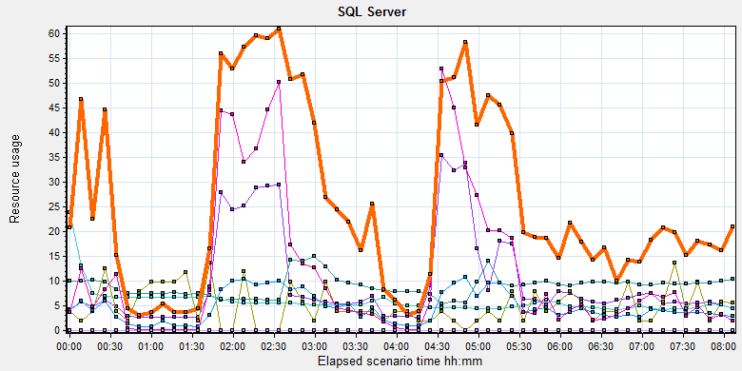

|  |  |  |  |  |  |  |
| --- | --- | --- | --- | --- | --- | --- |
| Color | Scale | Measurement | Minimum | Average | Maximum | Std. Deviation |
|  | 1 | Average Latch Wait Time (ms) (MSSQL$GCPACSWS|Latches):10.184.129.108 | 0.071 | 9.822 | 339.12 | 15.78 |
|  | 1000 | Latch waits/sec (MSOLAP$GCPACSWS|Locks):10.184.129.108 | 0 | 0.005 | 0.358 | 0.04 |
|  | 0.01 | Latch Waits/sec (MSSQL$GCPACSWS|Latches):10.184.129.108 | 0 | 895.222 | 3210.907 | 449.088 |
|  | 0.001 | Lock Memory (KB) (MSSQL$GCPACSWS|Memory Manager):10.184.129.108 | 3928 | 5868.252 | 23928 | 2944.787 |
|  | 1 | Lock Timeouts (timeout > 0)/sec (MSSQL$GCPACSWS|Locks \_Total):10.184.129.108 | 0 | 0 | 0 | 0 |
|  | 10 | Lock Timeouts/sec (MSSQL$GCPACSWS|Locks \_Total):10.184.129.108 | 0 | 0.474 | 13.617 | 0.876 |
|  | 0.1 | Lock Wait Time (ms) (MSSQL$GCPACSWS|Locks \_Total):10.184.129.108 | 0 | 118.467 | 14332.015 | 541.824 |
|  | 1 | Lock waits/sec (MSOLAP$GCPACSWS|Locks):10.184.129.108 | 0 | 0 | 0 | 0 |
|  | 100 | Lock Waits/sec (MSSQL$GCPACSWS|Locks \_Total):10.184.129.108 | 0 | 0.259 | 16.274 | 0.486 |

There are 895 latches every seconds during the testing work( Latch Waits/sec (MSSQL$GCPACSWS|Latches)). That means there are many recourse compete exist in the system. There are also has some locks and lock time out issues. Some SQL statement needs to enhance to fix these issues.

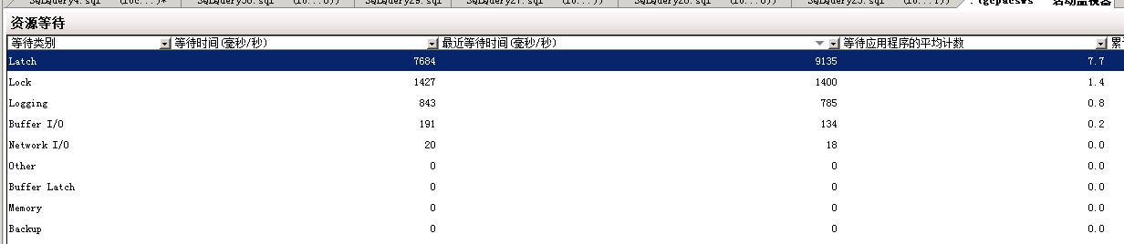

QA team guesses these issue caused by the store procedure which to synchronize upload files in wggc. The SQL statement will query the result which records need to update every 5 seconds. The SQL will full scan the main work flow table. It will lock the tables and other operations like print, change status and query will block by the SQL statement.

We captured some SQL statements which use too much system resource in testing work. There are some SQL belong to this store procedure .



We suggest develop team to resolve the issue as soon as quickly.

## Test Conclusion

We executed the performance testing scenario for 8 hours. The CPU resource has the bottleneck and some SQL statement need to enhance and change design. The cloud film service do not influence the operations of PS. We will continue the testing works for B24.

I collect some SQL statements which cause much resource during the testing works. Develop team need to review and try to resolve them as possible:

